Project Design Phase

Problem - Solution Fit Template

Date | 21 February 2026
Team ID | LTVIP2026TMIDS77557
Project Name | Calculating Family Expenses using Service Now
Maximum Marks | 2 Marks

Problem - Solution Fit Template:
The Problem–Solution Fit occurs when a real user problem is clearly understood and the proposed solution effectively addresses it. In this project, the identified problem is the difficulty families face in manually tracking and calculating their expenses, which often leads to errors and poor financial planning. The proposed ServiceNow-based Family Expense Management System provides an automated, accurate, and user-friendly way to record, categorize, and calculate expenses.
Purpose:
- To solve a real and recurring problem that affects family financial management.
- To ensure faster adoption of the solution by aligning it with users’ existing behaviors and needs.
- To refine communication and design by focusing on user pain points and motivations.
- To build user trust by providing consistent, accurate, and time-saving features.
- To understand the current expense management challenges and create a digital solution that simplifies and improves them.

Template:
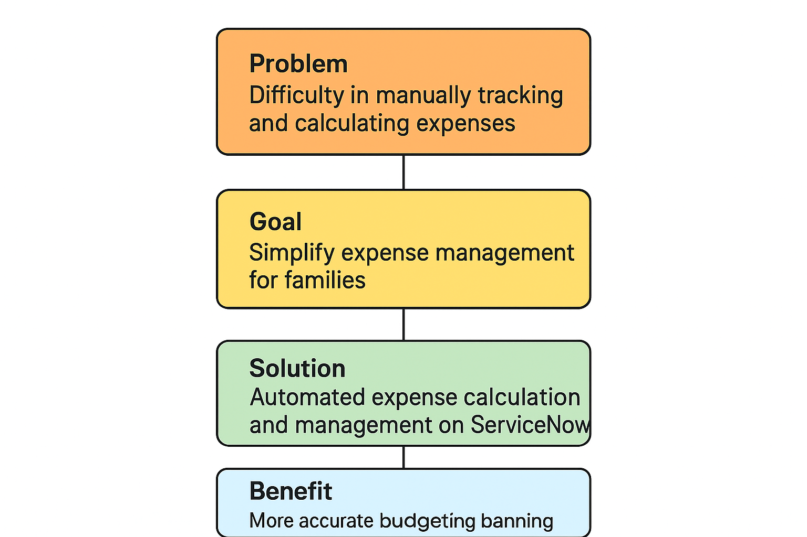

The project “Calculating Family Expenses using ServiceNow” addresses the common challenge families face in manually tracking and calculating their daily, monthly, and yearly expenses. Manual methods are often time-consuming, error-prone, and lack consolidated insights for budgeting and financial planning.
By developing an automated expense calculation and management system on the ServiceNow platform, users can easily record expenses, categorize them, and generate real-time reports. The system ensures accuracy, saves time, and provides visual dashboards to help families understand their spending patterns and make informed financial decisions.
This solution not only simplifies expense management but also leverages ServiceNow’s workflow automation, data visualization, and secure storage capabilities to provide a reliable, scalable tool for modern households.
.

